Checklist of documents for FMCS application

 | ALL FOREIGN LANGUAGE DOCUMENTS ARE REQUIRED ALONG WITH ENGLISH TRANSLATION | Received (YES/NO) | REMARKS
1 | Application form
2 | Factory Registration Certificate / Tax certificate of the company
3 | Authority letter in favor of signatory (in case application signed by any person other than CEO).
4 | List of Raw material ( format below )
5 | List of Plant & Machinery. ( format below )
6 | List of Testing Equipments. ( format below )
7 | Process out sourcing agreement. ( if any manufacturing process is outsourced to a third party)
8 | Valid calibration certificates (Min. validity upto 3 months from the date of recording of application).
9 | Quality Control Personnel –education Certificate, appointment letter, contact details and Company ID
10 | Raw Material Test Record
11 | Plant Layout.(along with area for lab demarcated )
12 | Finished Product / Sample Test Report (Can be as per IS / EN / ASTM or any other international standards.)
13 | In house test reports according to the clauses applicable form the Indian Standard
14 | ISO certificate or quality manual
15 | Manufacturing process flowchart
16 | Application fees receipt of amount paid to BIS

Note: Please go through this list thoroughly and provide documents accordingly so that we can minimize the chances of any query from BIS and request you to please send the documents in a single mail so that there is no confusion.
Formats:

- LIST OF MACHINERY:

- RAW MATERIAL LIST:

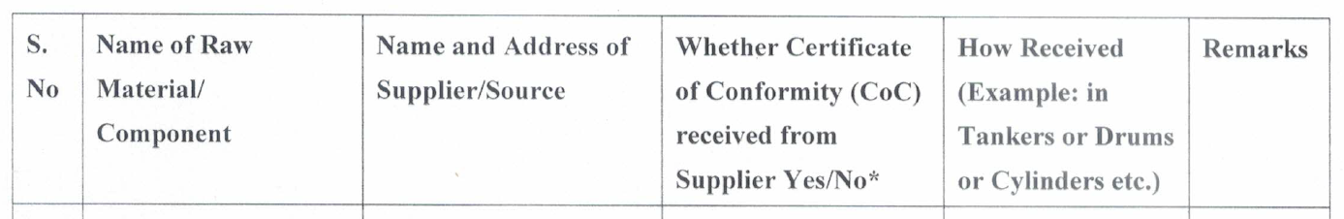

- TEST EQUIPMENT LIST FORMAT:

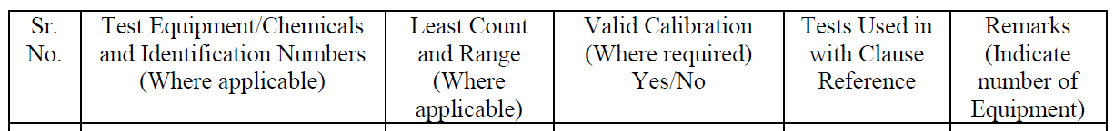

- INTERNAL TEST REPORT FORMAT:

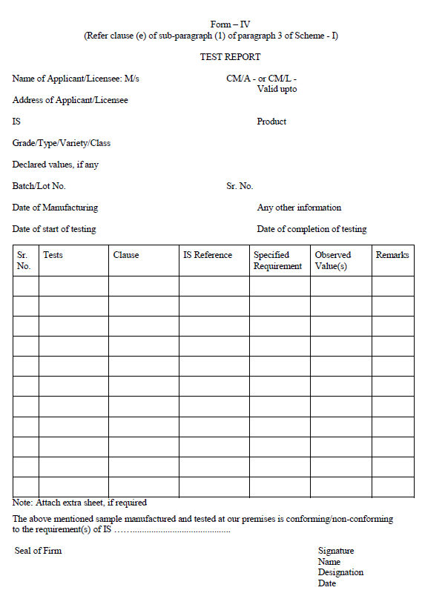

- APPOINTMENT LETTER FORMAT ( Not required in this format if the company already has issued an appointment letter to the quality in-charge) :

Appointment Letter:

To : [ Name of the person ] Govt ID number :

On behalf of [ your company's name ] , we hereby inform you that you are appointed as Lab in-charge in our company, Details as follows:

1.) Position :
2.) Monthly Salary : ( Optional )
3.) Annual Bonus :
4.) Leaves allowed :
5.) Working hours :
6.) Date of Joining :

In the best interest of [ company name ] , we will require your confirmation on this as soon as possible.

We look forward to you being a part of our team.

( Signature )
( Person’s name )
( Designation of the person )

